# Lab 2a: HTML5 and tables

Goal: Practice Advanced HTML Tables and Forms.

1. Create a technology news website’s homepage using HTML5 semantic elements as the one shown below (the style is not important for now):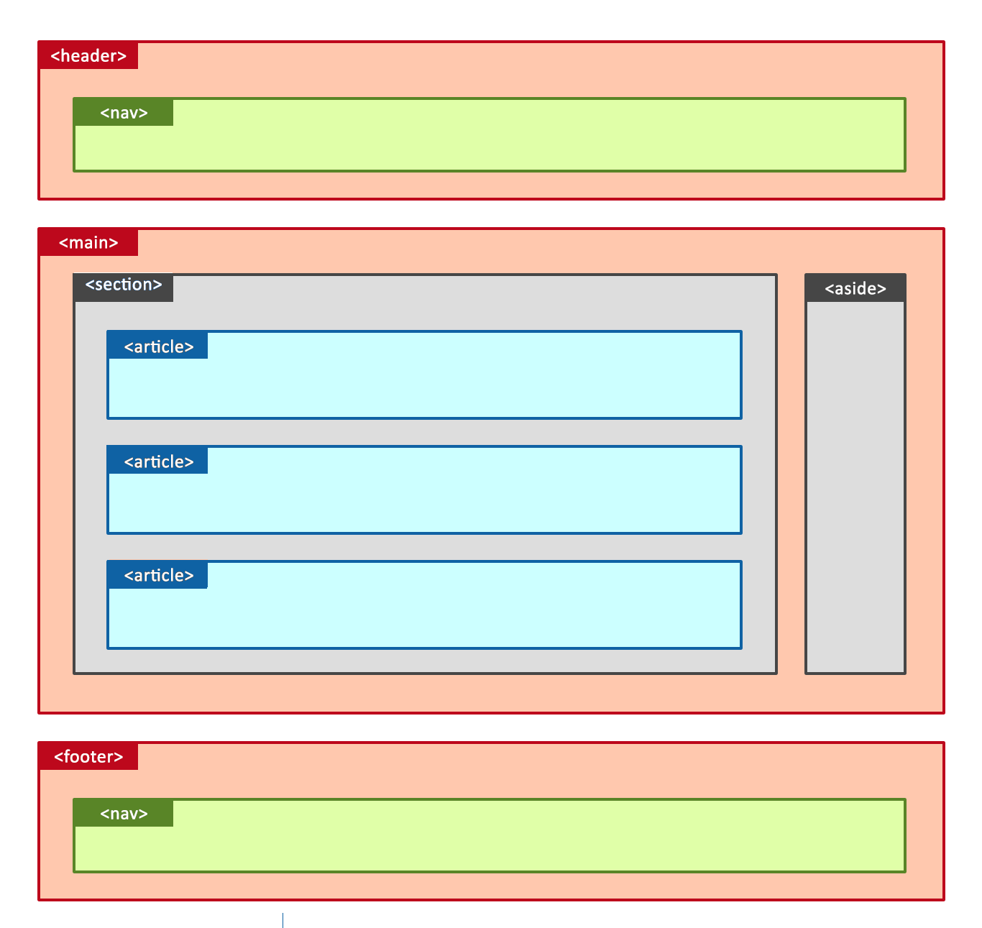

You can clone the following example:

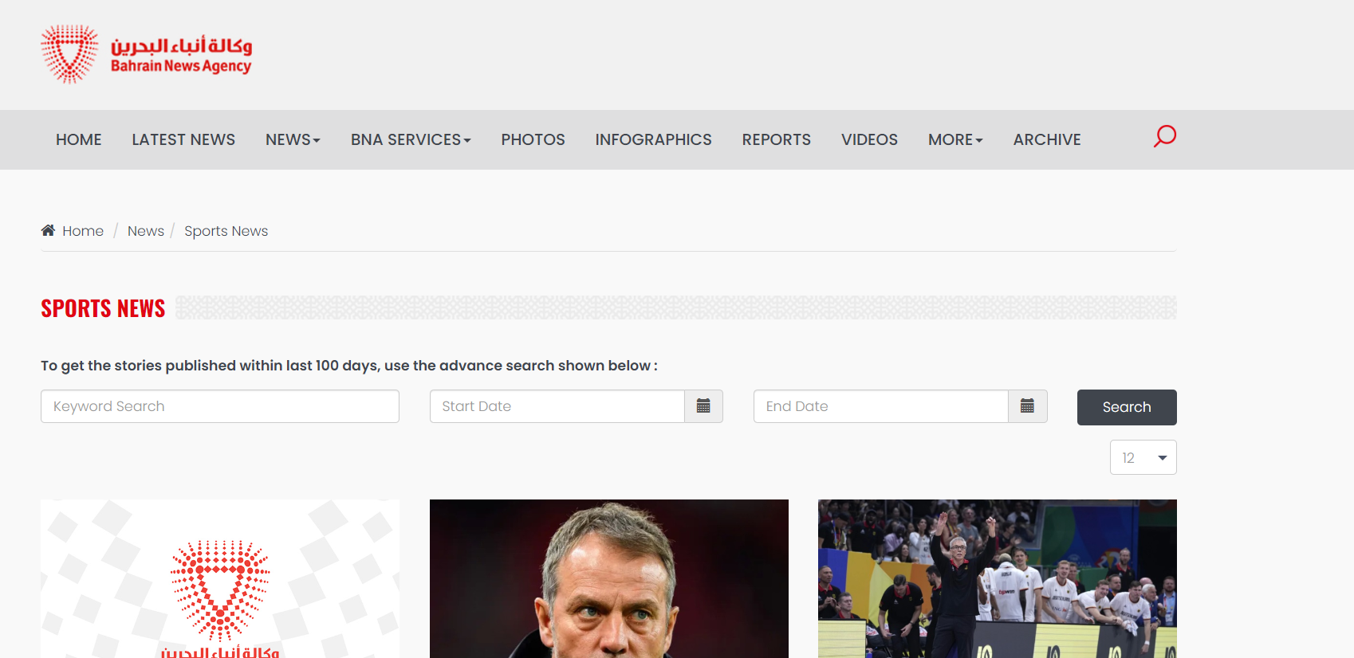

……

1. Create an HTML table that displays your weekly schedule:

|  |  |  |  |  |  |
| --- | --- | --- | --- | --- | --- |
|  | Sunday | Monday | Tuesday | Wednesday | Thursday |
| 8:00 – 9:00 |  |  |  |  |  |
| 9:00 – 10:00 | Course A |  | Course B |  |  |
| 10:00 – 11:00 |  |  | Course A |  |  |
| 11:00 – 12:00 |  |  |  |  |  |
| 13:00 – 14:00 | Course C |  | Course C | Course B |  |
| 14:00 – 15:00 |  |  |  |  |  |
| 15:00 – 16:00 |  |  |  |  |  |
| 16-00 to 19-00  (Extracurricular) | Soccer |  | Ping-pong |  |  |
|  |  |  |
|  |  |  | Swimming pool |  |

END.